**NAME: FILZA KHAN TAREEN**

**BATCH: BESE 27-C**

**COURSE: COMPUTER NETWORKS**

**LAB 11-C:**

Routing Information Protocol (RIP) is a distance-vector routing protocol that is used to exchange routing information between devices on a network. It is a simple and widely-used protocol that is supported by a wide range of networking devices.

In a distance-vector routing protocol, each device on the network maintains a routing table that contains a list of destinations and the corresponding next hop to reach those destinations. Devices exchange their routing tables with their neighbors at regular intervals, and each device updates its own routing table based on the information it receives.

RIP uses a metric called hop count to determine the best route to a destination. The hop count is the number of intermediate devices that must be traversed to reach the destination. A route with a lower hop count is considered to be a better route than a route with a higher hop count.

RIP has several limitations, including a maximum hop count of 15, which limits the size of the network that it can support. It also has a slow convergence time, meaning that it can take a long time for the routing tables to be updated when there is a change in the network. Despite these limitations, RIP is still widely used in small and medium-sized networks due to its simplicity and widespread support.

The configuration of Routing Information Protocol (RIP) on a Cisco router involves several steps:

1. Enable RIP on the router by entering the router rip command in global configuration mode.
2. Define the network(s) that will be advertised by the router using the network command. This command specifies the network address and subnet mask for the interfaces that will be included in the RIP domain.
3. Configure the version of RIP that will be used by the router using the version command. This command specifies whether the router will use RIP version 1 or version 2.
4. (Optional) Configure the administrative distance for RIP routes using the distance command. This command specifies the priority of the RIP routes relative to other routing protocols.
5. (Optional) Configure split horizon to prevent the router from advertising routes back out the interface from which they were learned. This can be done using the no ip split-horizon command.
6. (Optional) Configure route summarization to reduce the size of the routing table. This can be done using the summary-address command.
7. Save the configuration to memory using the copy running-config startup-config command.

Once these steps have been completed, the router will begin advertising and receiving RIP routes. You can verify the configuration by using the show Ip route command to view the routing table.

**Configure RIP routing on both routers using these commands**

GAD(config)#router rip

GAD(config-router)#network 172.16.0.0 (network id of self)

GAD(config-router)#network 172.17.0.0 (network id of next hop)

GAD(config-router)#exit

GAD(config)#exit

GAD#Filza Khan Tareen BESE 27-C

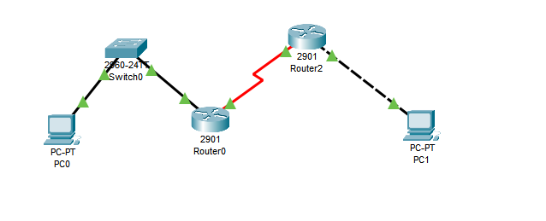

Top of Form